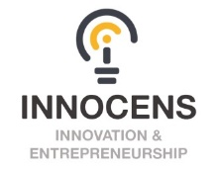
573965 Enhancing innovation competences & entrepreneurial skills in engineering education (InnoCENS)
http://gidec.abe.kth.se/InnoCENS/
__________________________________________________________

Innovation Business Idea

Submitted for Innovation Business Idea Competition

Preliminary title
Acronym
University represented
Team member 1  (= contact person) | First name, family name
 | Programme/Year
 | Email
 | Mobile No
Team member 2 | First name, family name
 | Programme/Year
 | Email
 | Mobile No
Team member 3 | First name, family name
 | Programme/Year
 | Email
 | Mobile No
Short description of the business idea
(max 5000 characters)
What is the novelty in your business idea?
Who are your customers?
Date of submission

